Azure DEV vs PRODUCTIOn Schema

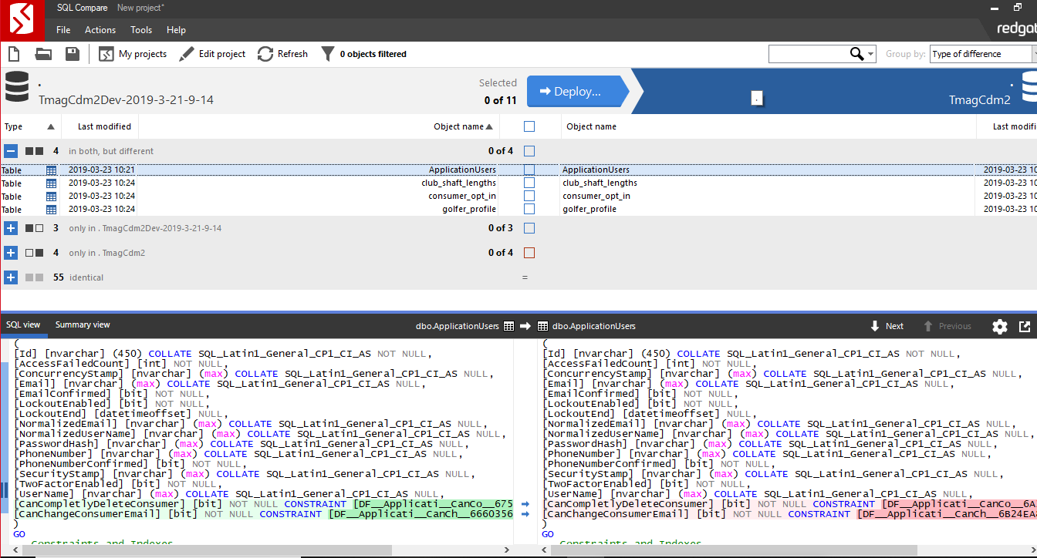

Azure DEV vs DEV Local

